INSERT INTO `employeedb`.`employee_address` (`Employee_id`, `Address`, `Postal_Code`) VALUES ('1', 'City Centre Dr.', 'L5A AQS');

INSERT INTO `employeedb`.`employee_address` (`Employee_id`, `Address`, `Postal_Code`) VALUES ('2', 'North York', 'LK6 W5E');

INSERT INTO `employeedb`.`employee_address` (`Employee_id`, `Address`, `Postal_Code`) VALUES ('3', 'Toronto', 'L4M 3V1');

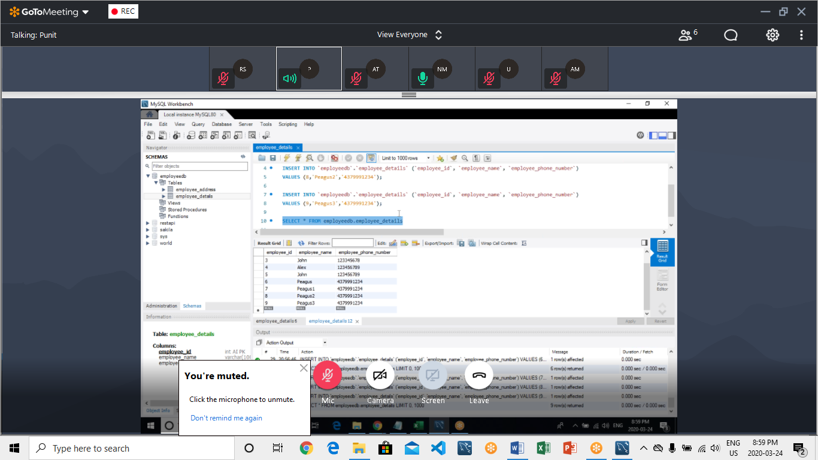

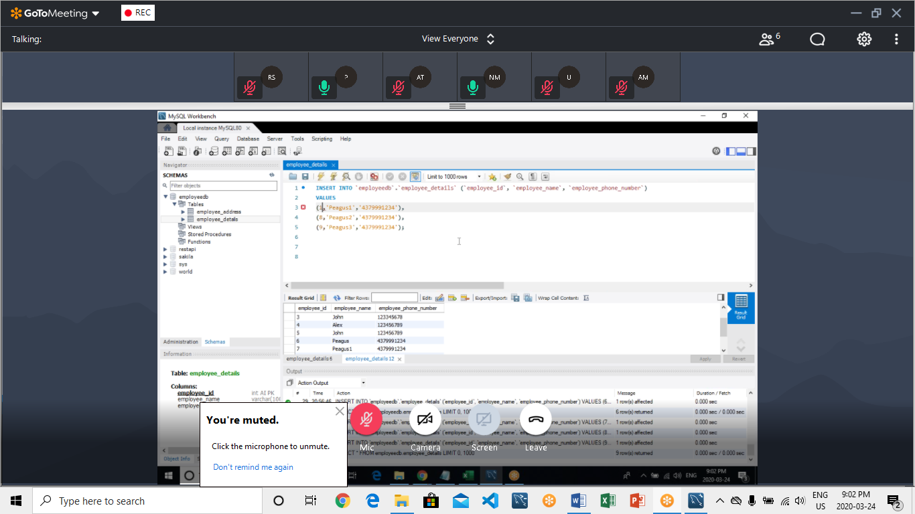

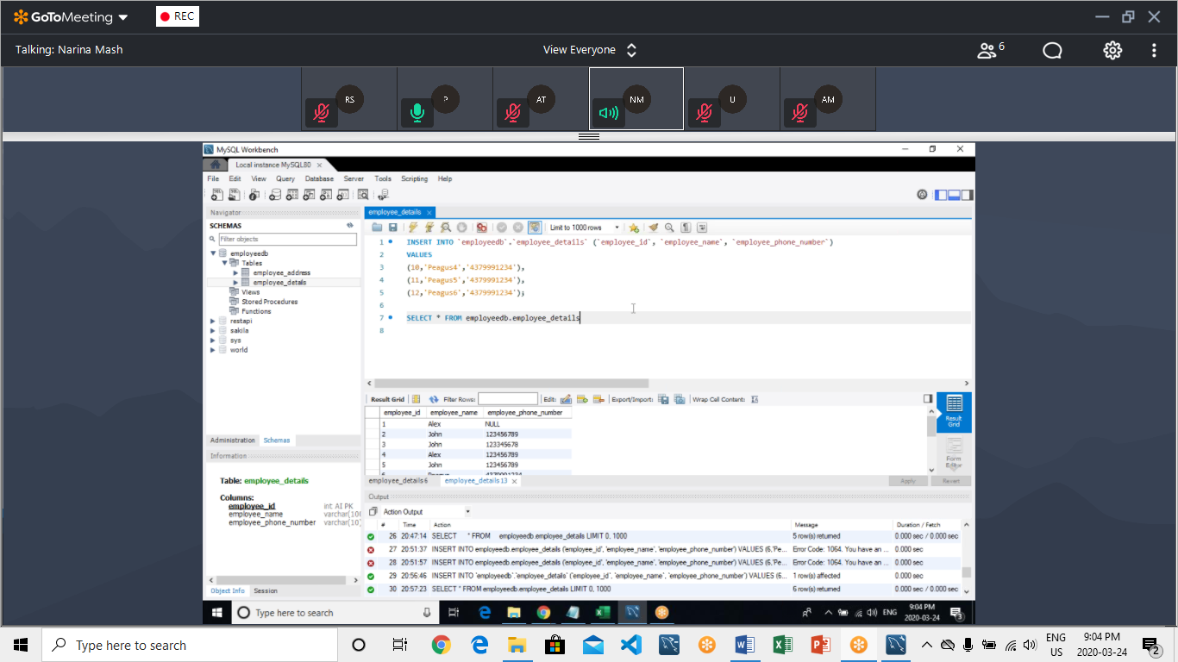

|  |
| --- |
| INSERT INTO `employeedb`.`employee_details` (`employee_id`, `employee_name`, `employee_phone_number`) |
|  |  | VALUES |
|  |  | (10,'Peagus4','4379991234'), |
|  |  | (11,'Peagus5','4379991234'), |
|  |  | (12,'Peagus6','4379991234'); |
|  |  |  |
|  |  | SELECT * FROM employeedb.employee_details |

INSERT INTO `employeedb`.`employee_address` (`Employee_id`, `Address`,`Postal_Code`)

VALUES

(4,'King City','M1N 5N6'),

(5,'Concord','N3T 4G3'),

(6,'Kingston','P4R 5T3');

SELECT * FROM employeedb.employee_address

UPDATE

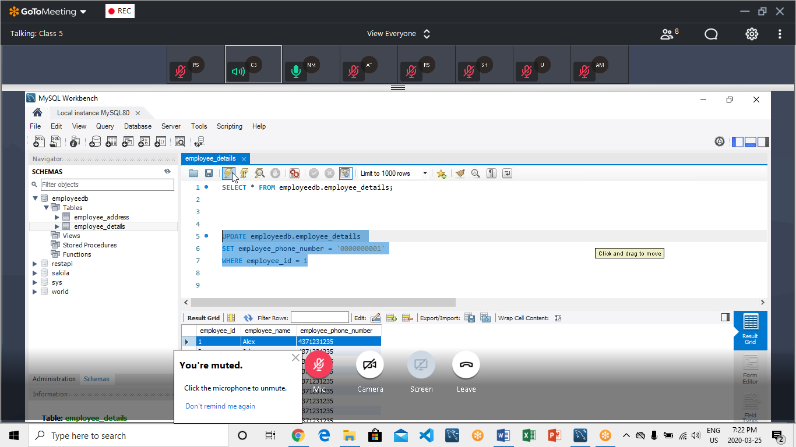

update employeedb.employeedetail

set employee_phone_no = 5555555555

where employee_id = 1

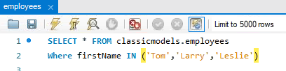

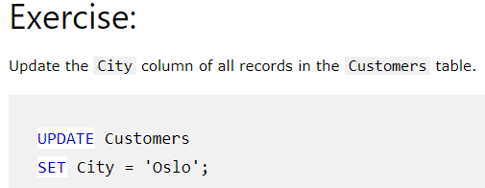

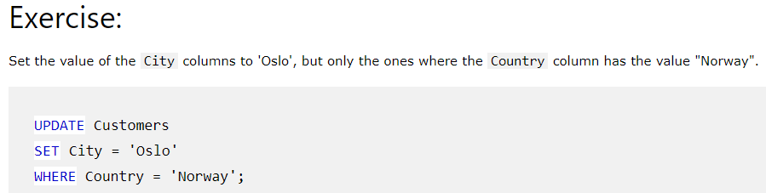

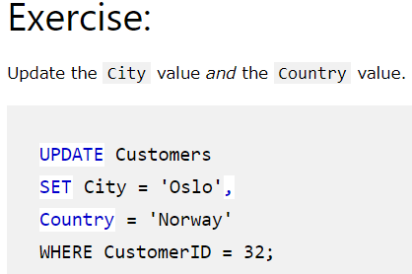

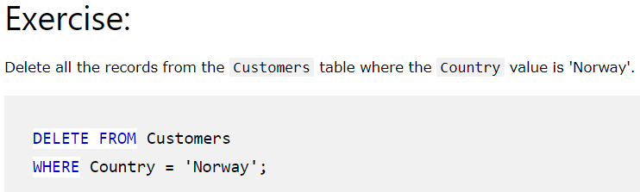

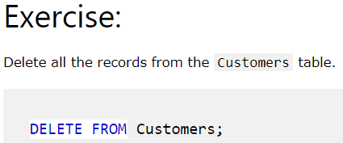

FUNCTIONS

